TMS Analysis Toolbox – Quick Start Guide

1. Download & Set Up
1.1 Download the Toolbox
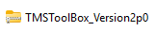
- Download the ZIP file provided.

1.2 Unzip
- Right-click → Extract All
- After extracting, your folder will contain:
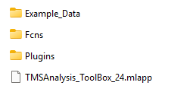
- App File
  - TMSAnalysis_Toolbox_24.mlapp
- Folders
  - Example Data — sample datasets used throughout this guide
  - Fcns — required functions for the Toolbox
  - Plugins — reserved for future user-developed add-ons

2. Open MATLAB & Launch the Toolbox
2.1 Open MATLAB 2023a
MATLAB 2023a is required,
Required MATLAB Packages: MATLAB Statistics and Machine Learning Toolbox, Signal Processing Toolbox, Mapping Toolbox
2.2 Navigate to the Toolbox Folder
MATLAB command window:
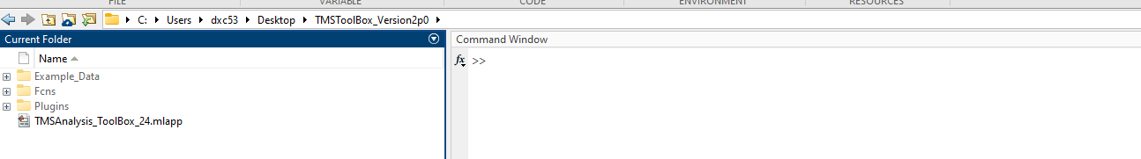
2.3 Run the App
In the command window, type:
TMSAnalysis_Toolbox_24
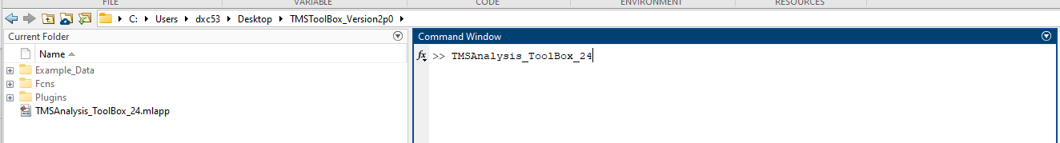
Press Enter.
The app may take a few seconds to open.
*May take a couple seconds for APP to pop-up

3. First-Time Setup
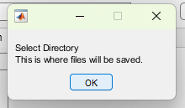
On your first launch, you’ll see a popup.’

1) Press OK
2) Create Toolbox Folder
- Create an empty folder anywhere on your computer.
- This folder will store all output generated by the Toolbox (plots, processed files, condition files, etc.).
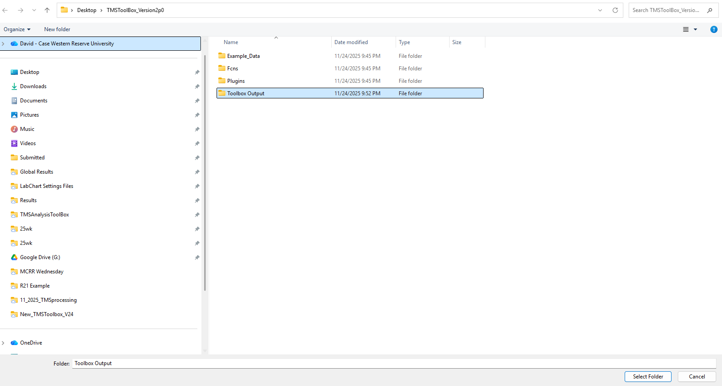

4. Load Raw Data
4.1 Supported Formats
The Toolbox supports LabChart, Brainsight, Signal, AcqKnowledge, Brainvision, Spike *Custom is under development
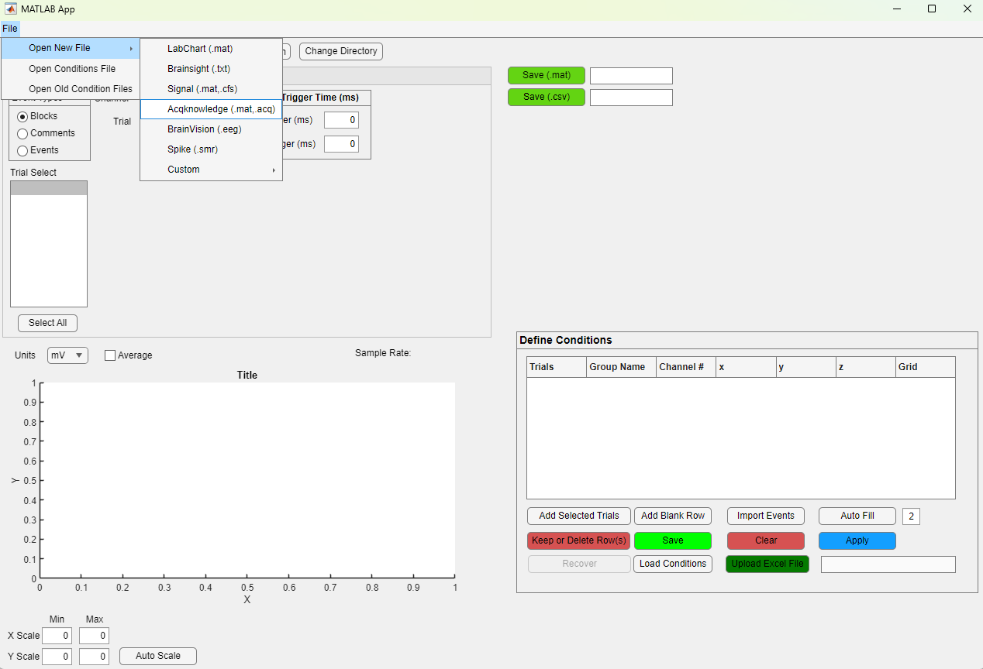
4.2 AcqKnowledge: Select Your Files
Supported File Type: ‘.mat’ and ‘.acq’
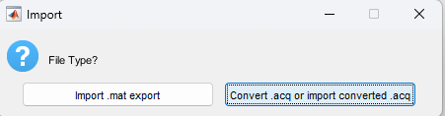
Use the file browser to load:
- A single file or
- Multiple files at once
Tip: Load files that logically “belong together” for your analysis (e.g., recruitment curve intensities, multiple sessions, multiple time points, etc.).
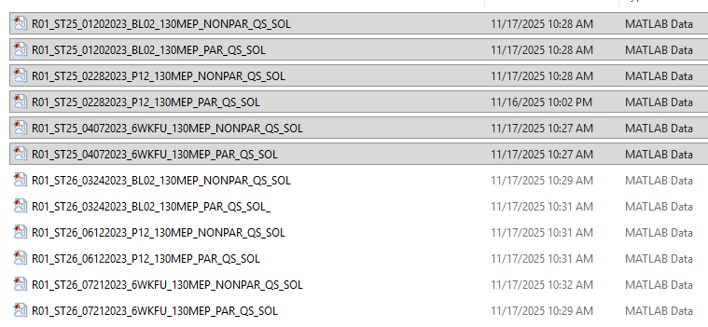

4.3 Example Dataset Structure
Example data, we will create condition files that are organized by Limb, Muscle, Time:
- Limb: Paretic vs. Non-paretic
- Muscle: Sol vs. TA
- Time: BL02, P12, 6WKFU
*Muscles are recorded in each file as separate channels
⚠ Important for Multiple Files
If you load multiple files:
You must know how many events (trials) are in each file and the order the files were loaded into the APP. More on this Later.
You can view this in:
- Number of Events: Lab notes or Load in individual files and determine number of events for each file
- File Order: The “File Order” panel
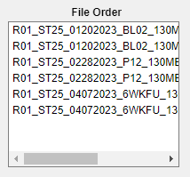

5. Event & Epoch Definition
The next steps guide users through defining how their data will be epoched. These settings are usually established during the experimental design phase. In this example dataset, AcqKnowledge does not support comment-based event markers, so that option is unavailable (grayed out).
Go to the Data Organization tab.
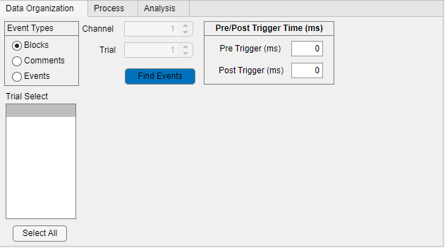

5.1 Block-Based Events
Choose Block when:
- Events represent “frames” of acquisition
- Pre/post durations were defined during acquisition
In the example dataset:
- Selecting Block + 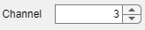 will show each “block”
- But you will want to use Events (Signal-based) for final epoching as a TTL was sent to Channel 3.
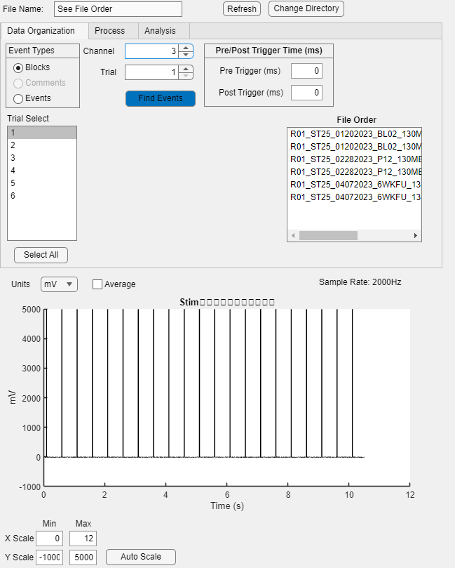

5.2 Signal-Based Events
Use this when you define events based on a signal, such as:
- TTL pulses
- Force onset
- EMG activation
You will specify:
- Event channel
- Threshold
- Search ISI (minimum time between events)
Example Settings
For this dataset:
Parameter | Value | Meaning
Event Channel | 3 | Where TTL pulses appear
Threshold | 1000 mV | Signal must exceed this to count as an event
Search ISI | 0.1 s | Used for noisy events. This reduces chances of random events
Define pre and post durations.
If you exceed available data, missing segments will appear blank.
Example Output
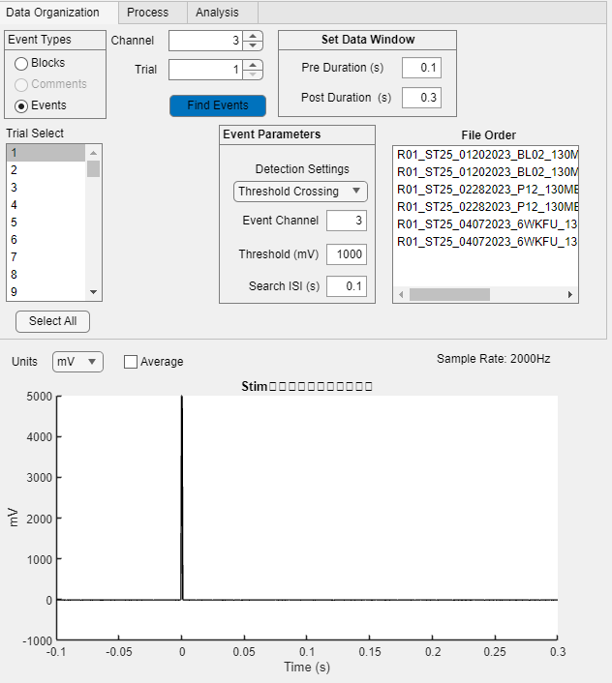
*121 events (“trials”) were detected.
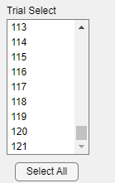

6. Understanding Trial Numbering
When loading multiple files:
- Trial numbers concatenate
- They do not reset per file
- IT IS IMPORTANT TO KNOW THE ORDER FILES WERE LOADED IN AND CAN BE VIEWED IN THE ‘FILE ORDER’ WINDOW

Example Dataset was typically 20 trials per file, but the first file had 21. It is very common to have more or less trials than planned based on how the data collection was going.
- File 1 → Trials 1–21
- File 2 → Trials 22–41
- File 3 → Trials 42–61
This cumulative structure is important when defining conditions.

7. Defining Conditions (Open Excel Template)
Open the provided Excel file.
You will see three tabs, including:
7.1 DefineCondition (Do Not Rename Tab Name)
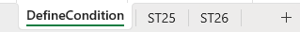
Row 1–2: Global naming conventions. Each column can have a unique identifier. Use this for global information about the study that should be tagged on to all naming conventions and will not change for the give file.
Example prefix:
7.2 Condition Definition Tabs (Example: ST25)
Each tab contains three components, each starting with *:
- Trial Numbers
- Naming Fields (columns X–AD)
- Channel Number (column AF)
General Structure
* Trial Numbers
* Naming Conventions
* Channel
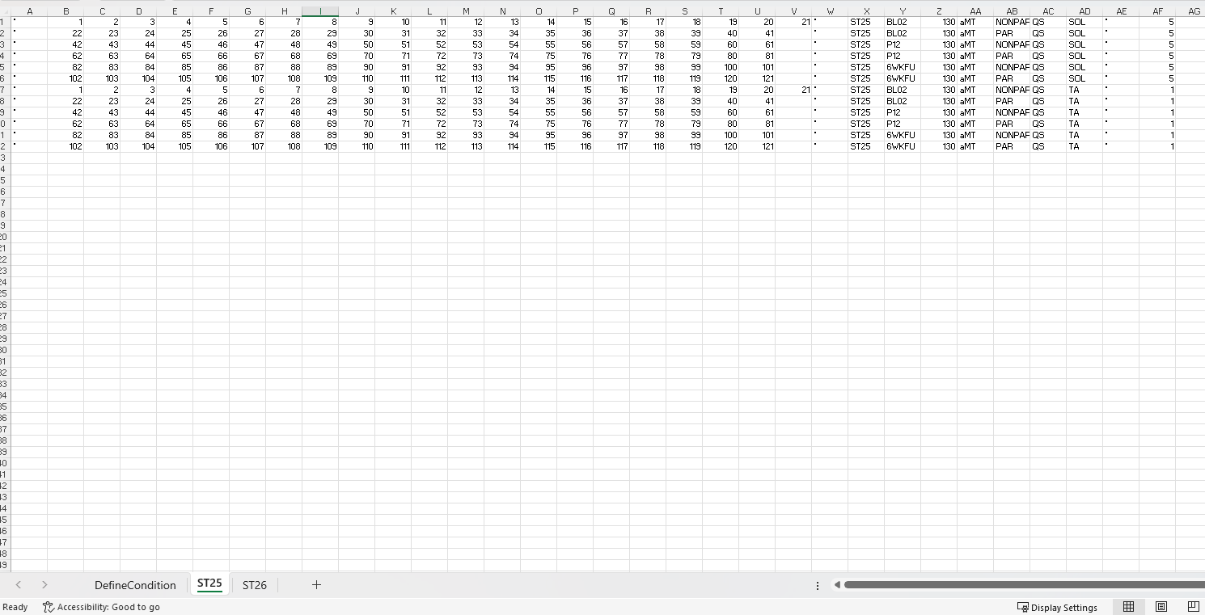
Example File
Trial #’s
Naming
Channel #
Each row = one condition.
One condition = Repeated trials for given “condition”
* = place in column before each component (i.e Trial #’s, Naming, Channel #)

Columns | Purpose
A–V | Trial numbers for each condition
X–AD | Naming fields (SUBID, Timepoint, Stim Intensity, etc.)
AF | Channel number (e.g., Sol=5, TA=1)
Each row = one condition.
Naming consistency is essential for downstream graphing & statistics.

8. Uploading Your Condition File
Steps:
- In the App, click
- Select your Excel file
- Use the dropdown to select the correct excel tab
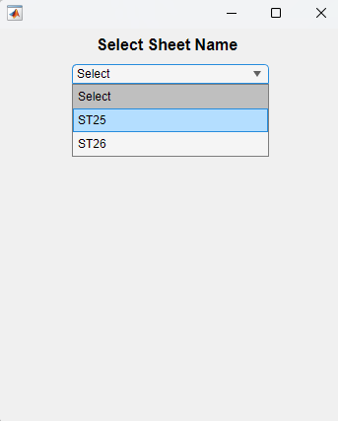
- Define Condition Event Settings
Of note:
The popup currently defaults to Event Type = Block, Pre (ms) = 0.15, Post (ms) = 0.15. Future update will automate this step but is still important if a dataset contains different types of events.
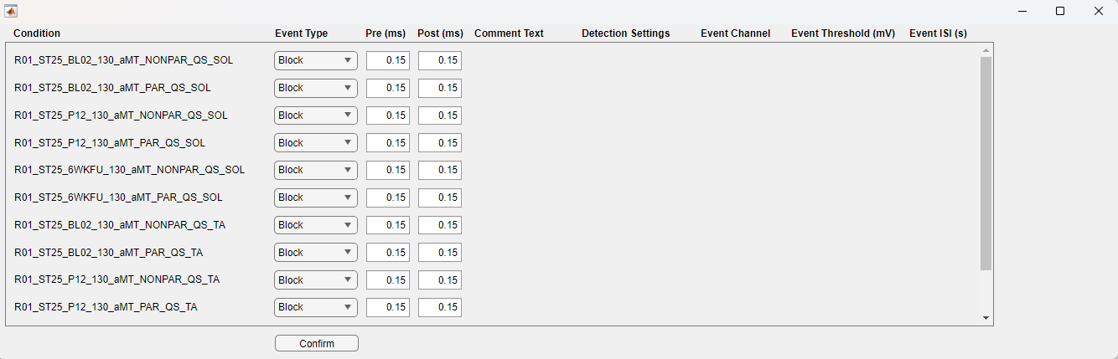
For this dataset, change all conditions as defined earlier
- Event Type: Events
- Event Channel: 3
- Threshold: 1000
- Search ISI: 0.1
- Pre/Post: 0.1/0.3
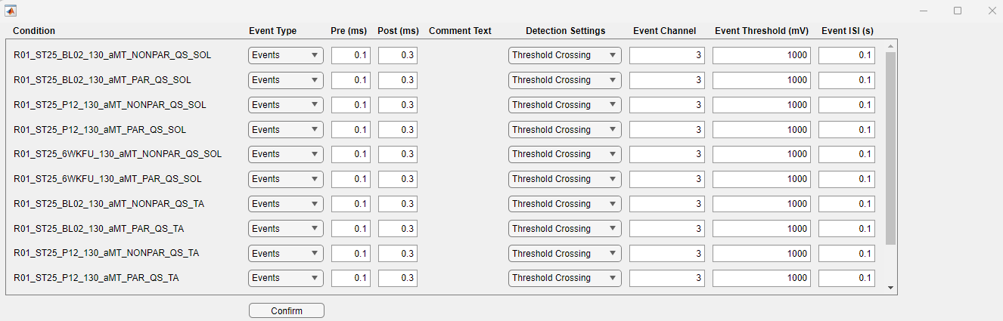
Press Confirm.
The App will update and press 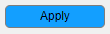:
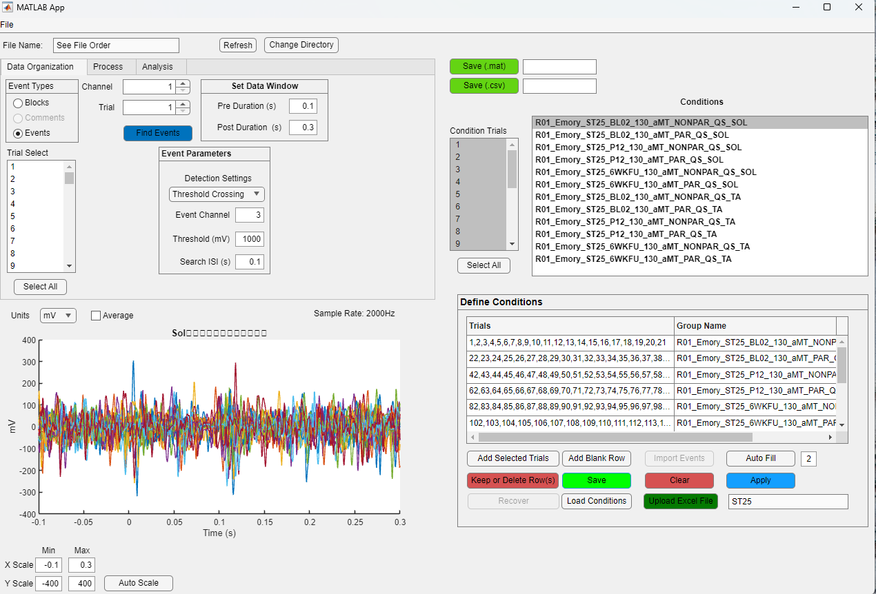

9. Save Condition File
Press 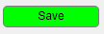 to save the newly generated condition file
Name your new file and press OK
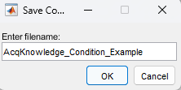
This file is saved in the output folder you created in step 3.

10. Load a Condition File
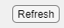 the App or restart the App
go to File → Open Condition File
(Use Open Old Condition Files only for Toolbox v1.0 legacy files.)
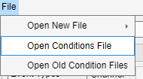

Your Toolbox save directory will open automatically, displaying the condition file you just generated. If you have created multiple condition files, you may select and load as many as needed at the same time.

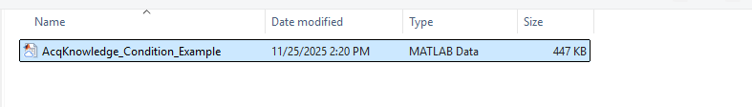

11. You Are Ready for Analysis

